**PAKISTAN PRIMARY SCHOOL**

**MATHEMATICS**

**Chapter -2: Arithmetic Operations**

**TOPIC:  Division**

**What is Division?**

The division is a method of distributing a group of things into equal parts. It is one of the four basic operations of arithmetic, which gives a fair result of sharing.

For example:

There are 16 balls and 4 boxes, how to put 16 balls into four equal sized boxes?

division ballsdivision ballsdivision balls

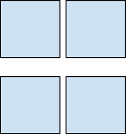

So, 16 divided by 4 =?

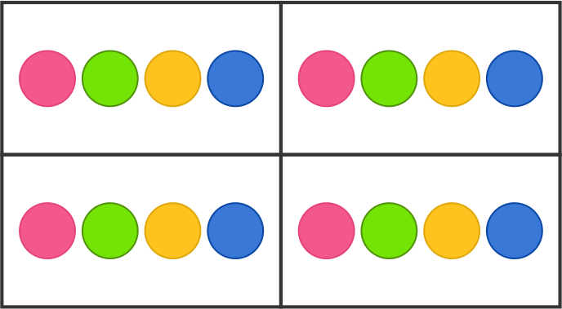

Therefore, 4 balls should be kept in each box.

**Mathematical notation for division**

There are various signs which can be used to indicate division such as ÷, /.

For example:

* 8 ÷ 2
* 8/2

**Special names for each character in Division**

Each part involved in a division equation has a special name.

**Dividend ÷ divisor = quotient**

[**Dividend**](https://www.splashlearn.com/math-vocabulary/division/dividend): The dividend is the number that is being divided in the division process.

[**Divisor**](https://www.splashlearn.com/math-vocabulary/division/divisor):The number by which dividend is being divided by is called divisor.

[**Quotient**](https://www.splashlearn.com/math-vocabulary/division/quotient): A quotient is a result obtained in the division process.

  18    ÷   3    =    6